EduGenie: Google Gemini Powered Learning Assistant
Submitted by: Arumparithi B | Team size: 1
Project Description:
EduGenie is a lightweight AI-powered educational assistant that simplifies learning through generative AI. Designed for students of all academic levels, EduGenie enables users to ask questions and receive smart, concise answers; understand complex concepts through simplified explanations; generate quizzes from topics or text; receive personalized learning recommendations; and summarize large educational passages.
Built with FastAPI for the backend and a simple HTML + CSS + JavaScript frontend, EduGenie uses Google Gemini through the Google Gen AI SDK for cloud intelligence and the lightweight LaMini-Flan-T5-783M model for optional local concept explanations, so it runs well even on modest hardware such as a Mac M1 or an ordinary laptop.
Scenarios
Scenario 1: A student who wants to know about oceans and rivers asks EduGenie "Which is the largest ocean?" and instantly receives a concise answer.
Scenario 2: A student wants to check their understanding of "The Pythagoras Theorem", selects Generate Quiz and answers three MCQs with instant feedback and a score.
Scenario 3: A learner exploring SQL requests a learning path and receives a structured plan from beginner to advanced topics with timelines, resources and practice projects.
Technical Architecture:
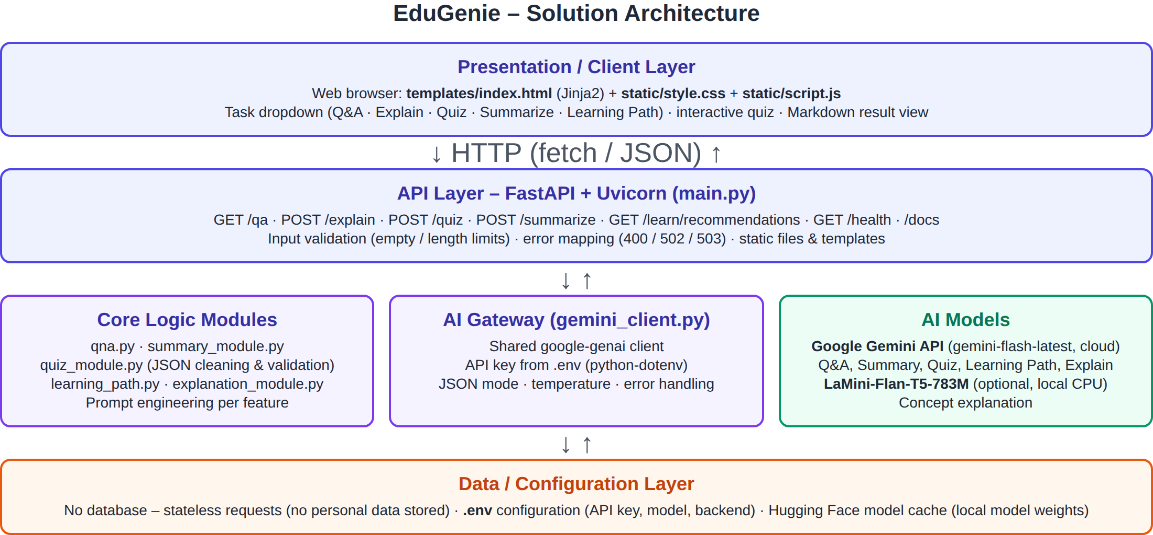
Figure 1: EduGenie technical architecture
Description: EduGenie uses a modular three-tier architecture. The browser-based frontend sends JSON requests to a FastAPI backend, which validates input, builds a task-specific prompt and calls Google Gemini through a shared client (or the local LaMini-Flan-T5 model for explanations). Responses are validated and returned as JSON for display. No database is used - EduGenie is stateless and stores no personal data.
Pre-requisites:
- Python 3.10+: https://www.python.org/downloads/ (tick "Add Python to PATH")
- FastAPI Framework: https://fastapi.tiangolo.com/
- Google Gemini API key: https://aistudio.google.com/app/apikey - Google AI for Developers documentation: https://ai.google.dev/
- Uvicorn (ASGI server): pip install uvicorn
- Jinja2 (HTML templating): pip install jinja2
- HTML, CSS and JavaScript: basic templating in /templates and /static
- Git & VS Code: version control and development environment
Project Workflow:
Milestone 1: Model Selection and Architecture
- Activity 1.1: Generate a Gemini API key and configure it securely in .env.
- Activity 1.2: Select AI models - Gemini (cloud) and LaMini-Flan-T5-783M (local).
- Activity 1.3: Define the architecture and folder structure.
- Activity 1.4: Set up the development environment.
Milestone 2: Core Functionalities Development
- Activity 2.1: Implement the five feature modules.
- Activity 2.2: Build the FastAPI backend endpoints.
Milestone 3: Frontend Development
- Activity 3.1: Build the web interface (HTML, CSS).
- Activity 3.2: Live integration with JavaScript.
Milestone 4: Deployment and Testing
- Activity 4.1: Run locally with Uvicorn.
- Activity 4.2: Functional, automated and performance testing.
Milestone 5: Conclusion

Milestone 1: Model Selection and Architecture
Activity 1.1: Generate a Gemini API Key
- Visit Google AI Studio (https://aistudio.google.com/app/apikey) and sign in with your Google account.
- Click "Create API key", choose or create a Google Cloud project, and copy the generated key.
- Copy EduGenie/.env.example to EduGenie/.env and paste the key: GEMINI_API_KEY=your_key_here
- The key is loaded automatically by gemini_client.py using python-dotenv. The .env file is listed in .gitignore so the key is never pushed to GitHub.
# Copy this file to ".env" (in this same EduGenie folder) and fill in your key.
# Get a free key at https://aistudio.google.com/app/apikey
GEMINI_API_KEY=your_gemini_api_key_here
# Gemini model to use. "gemini-flash-latest" always points to the newest Flash model.
# You can pin a specific model instead, e.g. GEMINI_MODEL=gemini-3.5-flash
GEMINI_MODEL=gemini-flash-latest
# When Gemini answers 503 "high demand" / 429 rate limit, EduGenie retries the same model
# GEMINI_MAX_RETRIES times (waiting ~2 s, then ~4 s), then tries these backup models in order.
# Set GEMINI_FALLBACK_MODELS=none to disable the fallback.
GEMINI_FALLBACK_MODELS=gemini-flash-latest,gemini-flash-lite-latest
GEMINI_MAX_RETRIES=2
# Explanation backend: auto | local | gemini
# auto -> use local LaMini-Flan-T5 if requirements-local.txt is installed, else Gemini
EXPLAIN_BACKEND=auto
# Load the local model at startup instead of on the first "Explain" request (true/false)
PRELOAD_LOCAL_MODEL=false
LOG_LEVEL=INFO

Activity 1.2: Select the AI Models
Model | Used for | Why
Google Gemini (gemini-flash-latest, via google-genai SDK) | Q&A, summarization, quiz generation (JSON mode), learning paths, explanation fallback | Advanced reasoning, structured JSON output, fast cloud inference, free tier. The project guide's gemini-1.5-pro is retired, so the latest Flash model is used (configurable via GEMINI_MODEL).
MBZUAI/LaMini-Flan-T5-783M (local, optional) | Concept explanation | Instruction-tuned, lightweight, runs on CPU / Apple Silicon without API cost.

Activity 1.3: Define the Architecture (Folder Structure)
EduGenie-AI/
|-- EduGenie/ # application
| |-- main.py # FastAPI app + API routes
| |-- gemini_client.py # shared Gemini client (google-genai)
| |-- explanation_module.py # concept explanation (LaMini-Flan-T5 / Gemini)
| |-- qna.py # question answering
| |-- quiz_module.py # quiz generation + JSON validation
| |-- summary_module.py # summarization
| |-- learning_path.py # learning recommendations
| |-- templates/index.html # frontend page
| |-- static/style.css # styling
| |-- static/script.js # frontend logic
| |-- tests/ # pytest tests + load_test.py
| |-- requirements.txt # core dependencies
| |-- requirements-local.txt # optional local model dependencies
| |-- .env.example # configuration template
| `-- pytest.ini
|-- Project Documents/ # phase-wise project documents
|-- .vscode/ # VS Code run / debug / test config
`-- README.md # setup, run and test guide

Activity 1.4: Set Up the Development Environment
python -m venv .venv
.venv\Scripts\Activate.ps1 # Windows (macOS/Linux: source .venv/bin/activate)
pip install -r EduGenie/requirements.txt
# optional local explanation model (~3 GB):
pip install -r EduGenie/requirements-local.txt

# Core EduGenie dependencies (Python 3.10+)
fastapi>=0.115,<1.0
uvicorn[standard]>=0.30
jinja2>=3.1
python-dotenv>=1.0
google-genai>=1.0
# Testing
pytest>=8.0
httpx>=0.27

Milestone 2: Core Functionalities Development
Activity 2.1: Module Implementation
Gemini Client (gemini_client.py). Shared Gemini client: every feature calls one generate() function that loads the key, applies JSON mode / temperature and converts SDK errors into friendly messages.
def generate(prompt: str, *, json_mode: bool = False, temperature: float | None = None) -> str:
"""Send `prompt` to Gemini and return the response text.
`json_mode=True` asks Gemini to reply with raw JSON (no Markdown).
Temporary errors (503 "high demand", 429 rate limits, 5xx, network errors) are retried
with exponential backoff, then the fallback models are tried in order.
Raises GeminiNotConfiguredError / GeminiBusyError / GeminiError on failure.
"""
api_key = get_api_key()
if api_key is None:
raise GeminiNotConfiguredError(
"Gemini API key is not configured. Copy EduGenie/.env.example to "
"EduGenie/.env and set GEMINI_API_KEY, then restart the server."
)
from google.genai import types
config = types.GenerateContentConfig(
temperature=temperature,
response_mime_type="application/json" if json_mode else None,
)
primary = get_model_name()
models = [primary] + get_fallback_models()
retries = get_max_retries()
last_exc: Exception | None = None
for model in models:
for attempt in range(retries + 1):
try:
response = _client(api_key).models.generate_content(model=model, contents=prompt, config=config)
except Exception as exc: # network errors, invalid key, quota, overload, unknown model ...
last_exc = exc
code = _error_code(exc)
if _is_retryable(exc):
if attempt < retries:
delay = RETRY_BASE_DELAY * (2 ** attempt) + random.uniform(0, 1)
logger.warning("Gemini %s busy (%s); retry %d/%d in %.1fs", model, code or exc, attempt + 1, retries, delay)
_sleep(delay)
continue
logger.warning("Gemini %s still busy after %d retries", model, retries)
break # try the next (fallback) model
if code == 404: # model name not available for this key - try the next model
logger.warning("Gemini model %s not found; trying the next model", model)
break
# Not temporary (invalid API key, bad request, ...): retrying will not help.
logger.error("Gemini request failed: %s", exc)
raise GeminiError(f"Gemini request failed: {_error_message(exc)}") from exc
if model != primary:
logger.warning("Answered with fallback model %s because %s was unavailable", model, primary)
text = _extract_text(response)
if not text:
raise GeminiError(
"Gemini returned an empty response (it may have been blocked by safety filters). "
"Try rephrasing your input."
)
return text.strip()
if last_exc is not None and _error_code(last_exc) == 404:
raise GeminiError(
f"Gemini model '{primary}' was not found for this API key. Set GEMINI_MODEL in "
f"EduGenie/.env to a model listed in Google AI Studio. ({_error_message(last_exc)})"
) from last_exc
tried = ", ".join(models)
raise GeminiBusyError(
"Gemini is very busy right now (high demand or rate limit). EduGenie retried automatically "
f"and also tried the backup models ({tried}). Please wait a minute and try again. "
f"Details: {_error_message(last_exc)}"
) from last_exc

Explanation Module (explanation_module.py). Uses LaMini-Flan-T5-783M when installed (EXPLAIN_BACKEND=auto/local); otherwise, or if the local model fails, it falls back to Gemini.
def explain_with_local_model(topic: str) -> str:
import torch
tokenizer, model = _load_local_model()
input_text = f"Explain the concept of '{topic}' in a simple and clear way for a school student."
inputs = tokenizer(input_text, return_tensors="pt", truncation=True, max_length=512)
with torch.no_grad():
outputs = model.generate(
**inputs,
max_new_tokens=200,
temperature=0.7,
top_k=50,
top_p=0.95,
do_sample=True,
)
return tokenizer.decode(outputs[0], skip_special_tokens=True).strip()
def explain_topic(topic: str) -> tuple[str, str]:
"""Return (explanation, source) where source is "local" or "gemini".
Raises gemini_client.GeminiError if every available backend fails.
"""
topic = topic.strip()
backend = get_backend()
if backend == "local" or (backend == "auto" and local_model_available()):
try:
explanation = explain_with_local_model(topic)
if explanation:
return explanation, "local"
except Exception:
logger.exception("Local explanation model failed; falling back to Gemini")
return explain_with_gemini(topic), "gemini"

QnA Module (qna.py). Answers academic and general-knowledge questions concisely.
QNA_PROMPT = """You are EduGenie, a friendly and accurate AI tutor for students.
Answer the student's question clearly and concisely (a short paragraph or a few bullet
points). Use simple language, give a small example when it helps, and do not invent facts.
If the question is not educational or is unclear, politely say so and suggest how to rephrase.
Question: {question}
"""
def answer_question_with_gemini(question: str) -> str:
"""Return a concise answer to `question`. Raises gemini_client.GeminiError on failure."""
return gemini_client.generate(QNA_PROMPT.format(question=question.strip()), temperature=0.3)

Quiz Module (quiz_module.py). Generates MCQs with four options in JSON. clean_json_block() removes Markdown code fences and parse_quiz() validates every question (4 options, answer must match an option, letter answers mapped to text).
def clean_json_block(text: str) -> str:
"""Remove Markdown ```json code fences (if any) around the model output."""
text = text.strip()
match = re.search(r"```(?:json)?\s*\n?(.*?)```", text, flags=re.DOTALL)
if match:
text = match.group(1).strip()
return text
def generate_quiz(text: str, num_questions: int = DEFAULT_NUM_QUESTIONS) -> list[dict]:
"""Generate a validated MCQ quiz from `text`. Raises gemini_client.GeminiError on failure."""
n = max(1, min(int(num_questions), MAX_NUM_QUESTIONS))
raw = gemini_client.generate(QUIZ_PROMPT.format(n=n, text=text.strip()), json_mode=True, temperature=0.4)
return parse_quiz(raw)[:n]

Summary Module (summary_module.py). Summarizes long passages into an overview plus key points.
def summarize_text(text: str) -> str:
"""Return a concise summary of `text`. Raises gemini_client.GeminiError on failure."""
return gemini_client.generate(SUMMARY_PROMPT.format(text=text.strip()), temperature=0.2)

Learning Path Module (learning_path.py). Creates a structured beginner-to-advanced plan adapted to the learner's level, with time estimates, resources, projects and a timeline.
def get_learning_recommendations(topic: str, level: str = "beginner") -> str:
"""Return a Markdown learning path for `topic`. Raises gemini_client.GeminiError on failure."""
level = level.lower().strip() if level else "beginner"
if level not in LEVELS:
level = "beginner"
prompt = LEARNING_PATH_PROMPT.format(topic=topic.strip(), level=level)
return gemini_client.generate(prompt, temperature=0.5)

Activity 2.2: Backend API with FastAPI
Endpoint | Method | Input | Output
/qa | GET | question (query) | {question, answer}
/explain | POST | {topic} | {topic, explanation, source}
/quiz | POST | {text, num_questions} | {quiz: [{question, options, answer, explanation}]}
/summarize | POST | {text} | {summary}
/learn/recommendations | GET | topic, level (query) | {topic, level, recommendation}
/health | GET | - | {status, gemini_configured, gemini_model, ...}

def validate_input(value: str | None, name: str, max_chars: int) -> str | JSONResponse:
value = (value or "").strip()
if not value:
return error(f"Please provide {name}.", 400)
if len(value) > max_chars:
return error(f"Input is too long ({len(value)} characters). The limit is {max_chars}.", 400)
return value
# Quiz Generation - POST API
@app.post("/quiz", tags=["learning"])
def quiz_api(body: QuizRequest):
text = validate_input(body.text, "text or a topic for the quiz", MAX_TEXT_CHARS)
if isinstance(text, JSONResponse):
return text
try:
quiz = generate_quiz(text, body.num_questions)
logger.info("Generated quiz with %d questions", len(quiz))
return {"quiz": quiz}
except gemini_client.GeminiError as exc:
return ai_error(exc)

Milestone 3: Frontend Development
Activity 3.1: Build the Web Interface
- index.html (Jinja2): task dropdown (Q&A, Explain, Quiz, Summarize, Learning Path), text area with character counter, quiz size and learning-level options, example chips, Submit and Clear buttons, result card.
- style.css: responsive layout from mobile to desktop, gradient header, styled buttons/inputs/result container, automatic dark mode, quiz option states (correct = green, wrong = red).
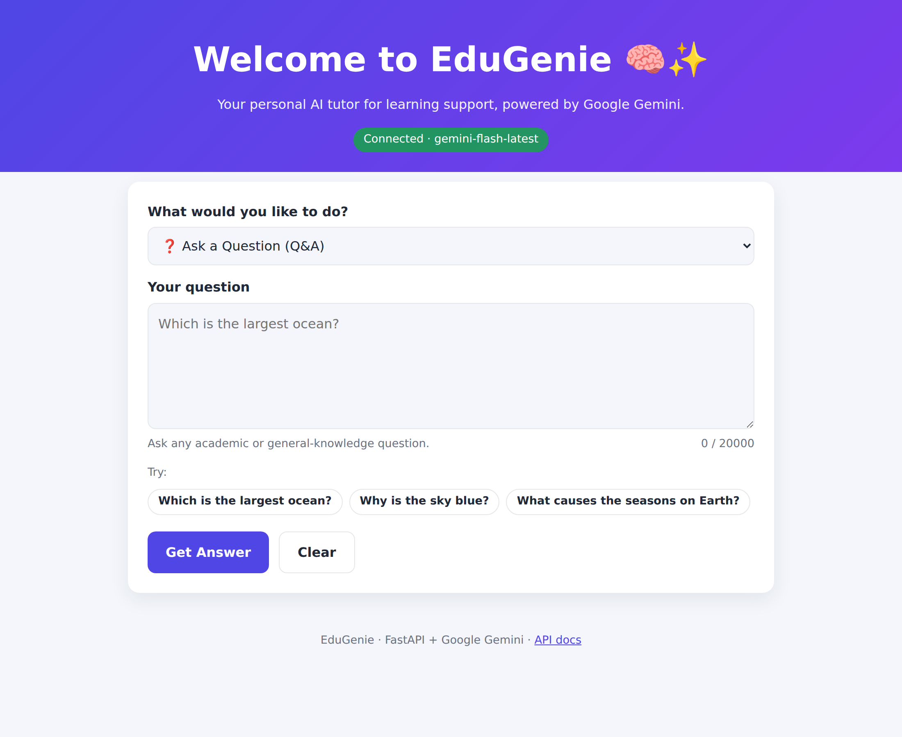
Figure 2: EduGenie home page
Activity 3.2: Live Integration
- script.js sends a fetch() GET/POST request to the matching FastAPI endpoint when the form is submitted (or Ctrl/Cmd + Enter).
- A loading spinner is shown while the AI works; the result appears below the form in real time.
- Text results are rendered from Markdown with all HTML escaped (XSS-safe); quizzes are rendered as clickable options with feedback and score.
- Errors from the API (empty input, missing key, Gemini failure) are shown in a red message box.

Milestone 4: Deployment and Testing
Activity 4.1: Run Locally
cd EduGenie
uvicorn main:app --reload
# then open http://127.0.0.1:8000 (API docs: http://127.0.0.1:8000/docs)

In VS Code, the same can be done with Run and Debug -> "EduGenie: Run server (uvicorn)" -> F5.
Activity 4.2: Functional Testing
Automated tests (pytest) mock the Gemini API, so they run without a key or internet and verify every endpoint, validation rule and error path.
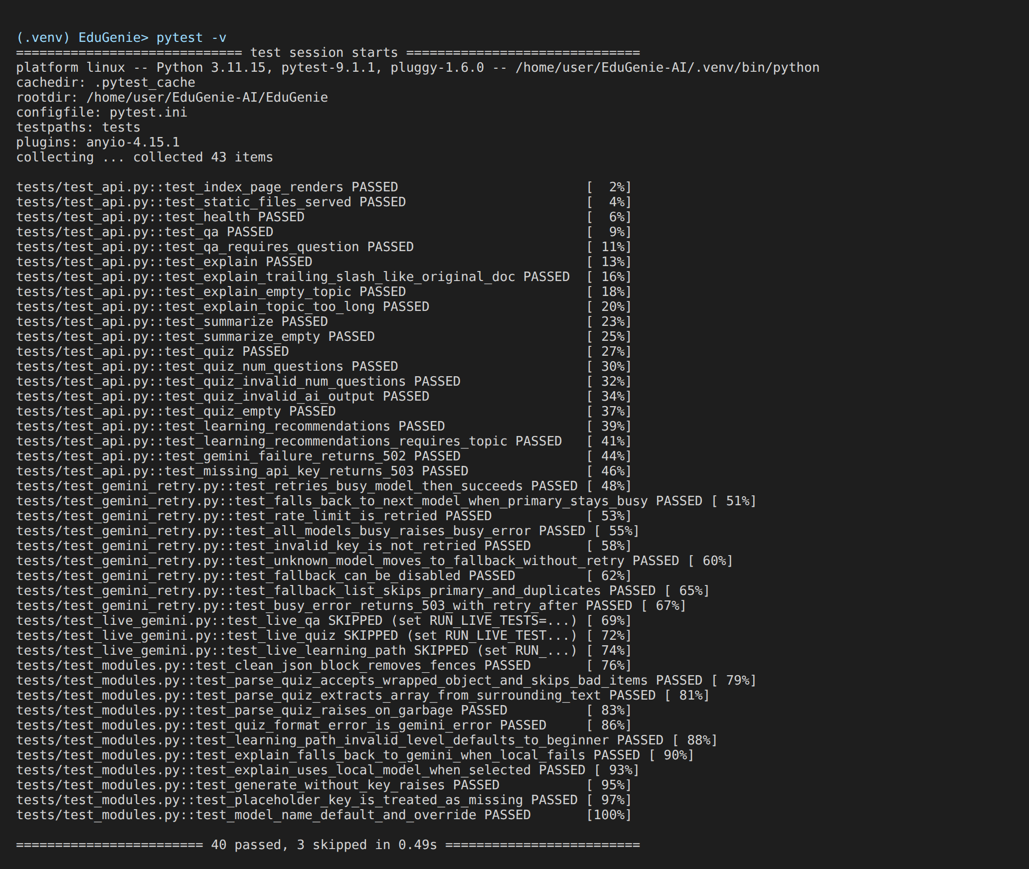
Figure 3: pytest results - 40 passed (3 live tests run only with RUN_LIVE_TESTS=1)
Exploring EduGenie:
Asking questions:
Select "Ask a Question", type a question such as "Which is the largest ocean?" and click Get Answer.
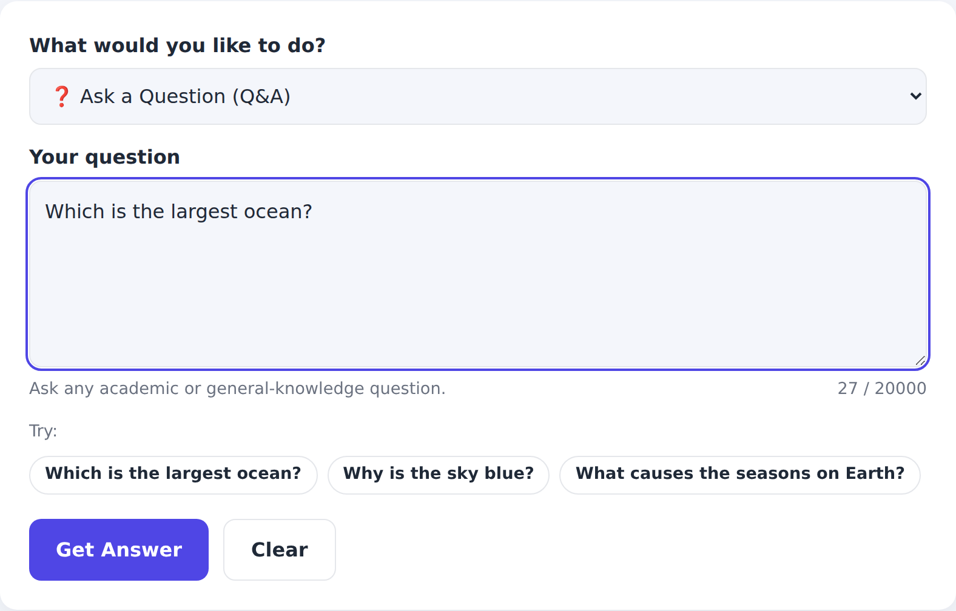
[Insert screenshot of the live AI result for "Asking questions" after running EduGenie with your Gemini API key]

Explanation of any topic:
Select "Explain a Concept" and enter a topic such as Photosynthesis. The badge shows whether Gemini or the local LaMini-Flan-T5 model answered.
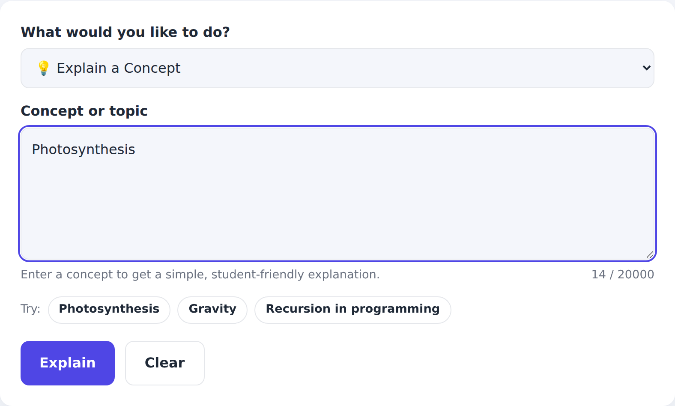
[Insert screenshot of the live AI result for "Explanation of any topic" after running EduGenie with your Gemini API key]

Summarising long paragraphs:
Paste a long passage and click Summarize to get a one-line overview and key bullet points.
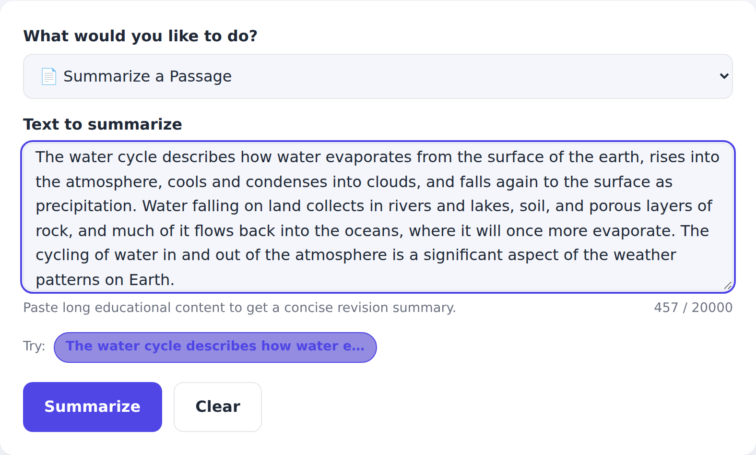
[Insert screenshot of the live AI result for "Summarising long paragraphs" after running EduGenie with your Gemini API key]

Generating quizzes:
Enter a topic or passage, choose 3, 5 or 10 questions and click Generate Quiz. Each question has 4 options; clicking an option shows whether it is correct (green) or wrong (red), the explanation and the running score.
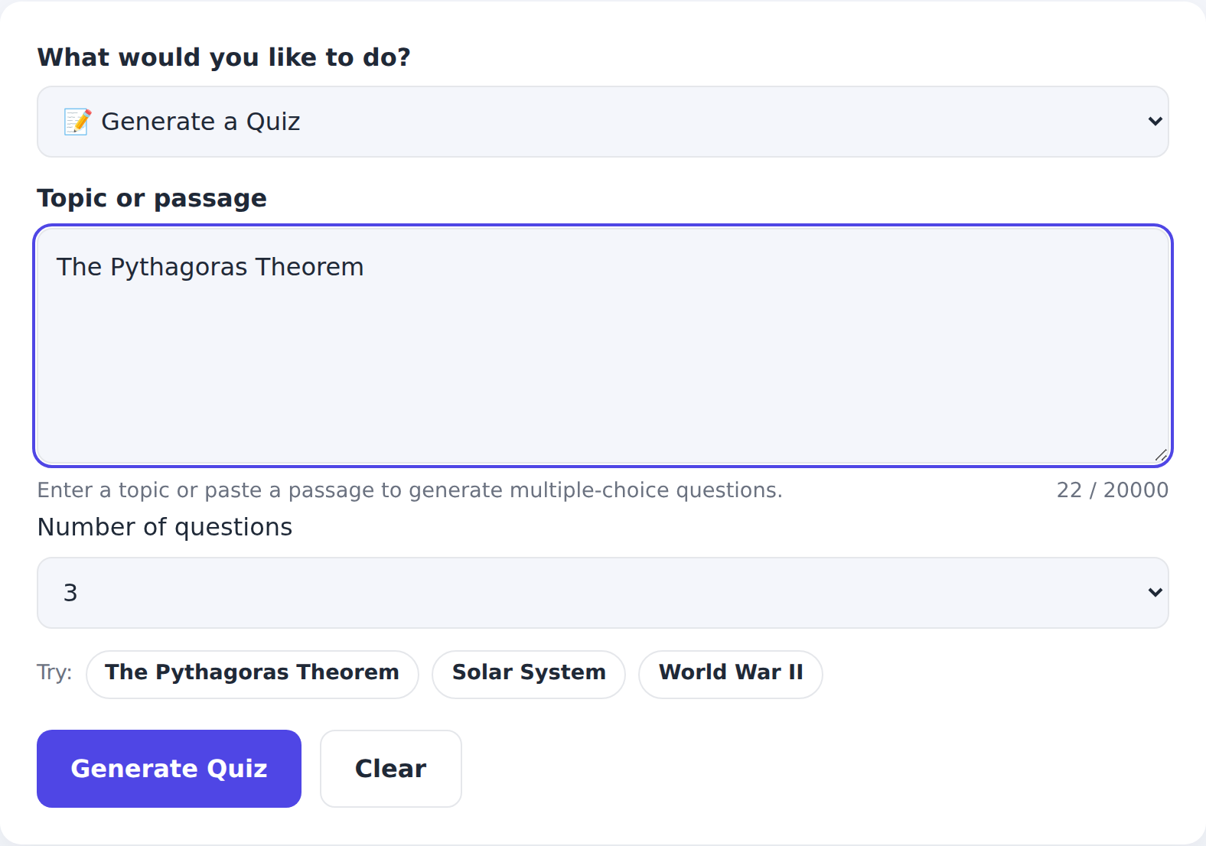
[Insert screenshot of the live AI result for "Generating quizzes" after running EduGenie with your Gemini API key]

Learning recommendations from beginner to advanced:
Enter a topic (e.g. SQL), choose the current level and click Get Learning Path to get topics, timelines, resources, practice projects and a weekly plan.
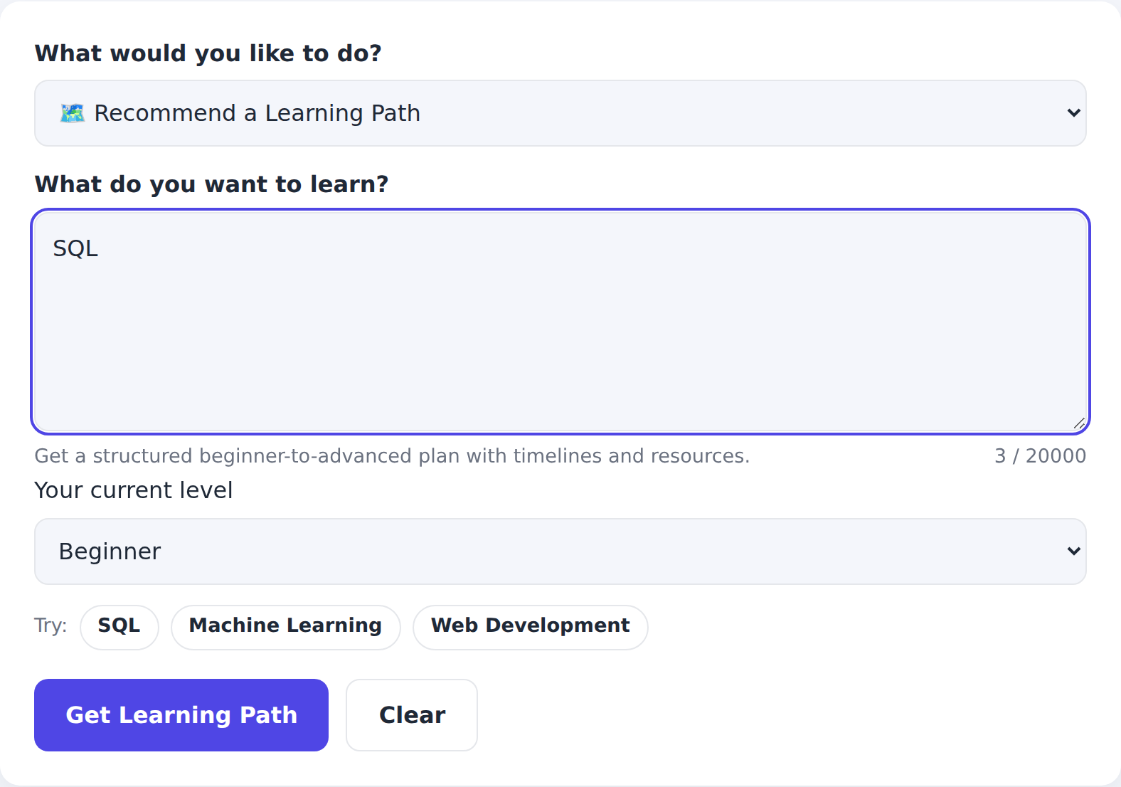
[Insert screenshot of the live AI result for "Learning recommendations from beginner to advanced" after running EduGenie with your Gemini API key]

Error handling:
If the API key is missing or invalid, or Gemini is unavailable, EduGenie shows a clear message instead of crashing:
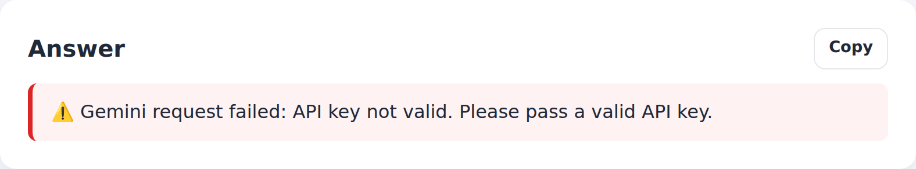
Mobile view:
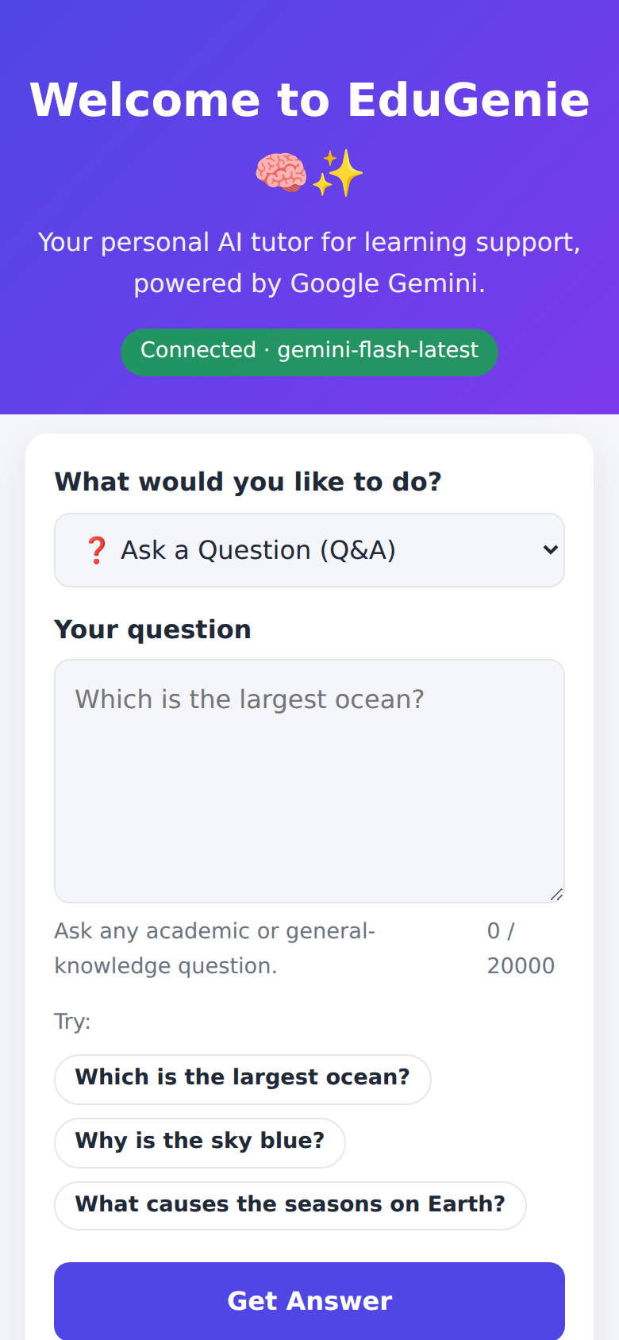

Conclusion:
EduGenie is a robust and accessible AI-powered educational assistant that combines Google Gemini's cloud intelligence with an intuitive, low-footprint web interface. It simplifies complex concepts, answers questions instantly, generates interactive quizzes, summarizes long passages and builds personalized learning paths - making quality learning support available to anyone with a browser.
The project achieved its milestones in AI integration, prompt engineering, API design, user-experience design and testing. Challenges such as keeping AI output reliable (solved with JSON mode and strict quiz validation), handling API errors gracefully, keeping the API key secure and supporting low-resource devices (optional local model, stateless design) provided valuable learning outcomes.
Future enhancements include voice-based interaction, multilingual support, a mobile application, progress-tracking dashboards, gamification (badges, streaks), user accounts with history, LMS integration (Moodle, Google Classroom) and image/PDF input for snapshot-based doubt solving.
Submitted by: Arumparithi B

